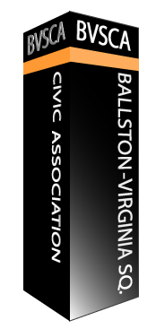
Ballston-Virginia Square
Civic Association
Membership Application
Date:
Name:
Street: City: State: Zip:
Email:
Phone (optional):
I'm interested in volunteering to help: Yes No
If yes, what is your area of interest

E-Mail, Mail or drop off completed application & dues to:
Giang Dang (Treasurer and Secretary of Member Records)
BVSCAtreasurer@gmail.com
3426 12th Road N
Arlington, VA 22201

***Dues: $10/person/year. Please make checks payable to BVSCA or Pay via Paypal to the bvscatreasurer@gmail.com ***

BVSCA membership is open to anyone who owns, leases or rents a residence within our boundaries.
